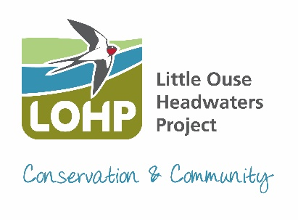
Little Ouse Headwaters Project
Ellie Beach – Conservation Manager
Thelnetham Windmill
Mill Road
Thelnetham
Diss
IP22 1JS
Email: ellie.beach@lohp.org.uk
Phone: 07919 912045
To find out more, become a member or donate visit www.lohp.org.uk

Annual Report for Blo’ Norton Parish Council

Last year the usual fen and reedbed management on Blo’ Norton Fen was successfully completed by contractors and volunteers. With an increase in the number of volunteers coming out with us over the last year we have been able to get even more jobs completed.

Over the winter we had to close the woodland boardwalk on Blo’ Norton Fen for a while to undertake emergency tree works to ash trees by the path which had Ash dieback and could drop limbs any moment. These were all completed by a specialist contratcor, and the boardwalk reopened in the new year.

Our second year of the reptile surveys on Hinderclay Fen and on Broomscot Common, saw us change the material that the reptile sheets were made of, using something longer lasting. Reptiles and amphibians were seen in low numbers and more commonly not seen under the reptile sheets, probably as a result of the hot summer and drought meaning creatures were coming out earlier/late to avoid the heat of the day or hiding away. We are going to continue the survey this year (2023) on both sites. We are continuing with our Water Vole surveys with the rafts moved onto the river between the ford and Hinderclay Fen. We still continue our monthly Riverfly Monitoring on the river at Hinderclay Fen and Scarfe Meadows and bird ringing continues on Hinderclay Fen.

The two new official Rights of Way, on Hinderclay Fen (Public Footpath 17) are being well used and provide a lovely walk through the silver birch woodland and around the edge of the heathland. We are still waiting for news from Suffolk County Council and Norfolk County Council about the progress of the new bridge. More details will follow once they are known.

Over recent weeks we have suffered a couple of incidents of vandalism, the sculpture on Blo’ Norton Fen by Swallow Bridge was twisted round, and discs removed, making it unsafe (we have now secured it), and the fencing near to Bob’s Bridge was pulled out of the ground and thrown in the river. This has now been rescued and we will be reinstalling it more securely once things have quietened down. A group of youths on bikes have been seen around the entrance to Bettys Fen on occasions.

2022 saw LOHP celebrate our 20th Anniversary. During the summer we held a celebration event in July, based around Parkers Piece (opposite Thelnetham Windmill). We had stalls, rural crafts, vintage tractors, art, children’s activities, guided walks, sheep dog demonstrations, refreshments and Thelnetham Windmill was open for tours. The event was a great success with over 500 people joining us throughout the day. Here’s to another 20 years.

Ellie Beach
LOHP Conservation Manager
11-05-2023

